**Machine Learning Algorithms**

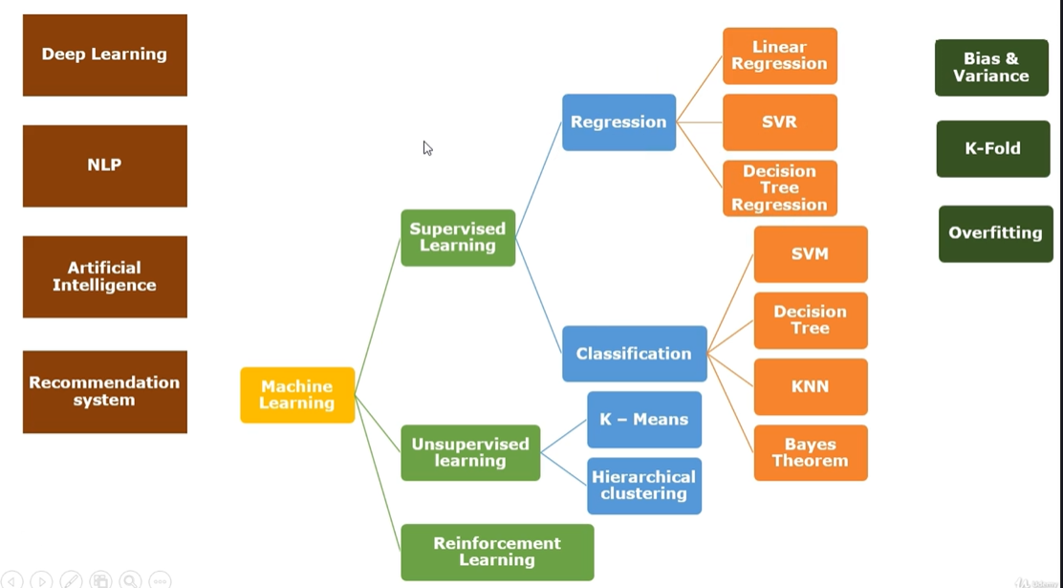

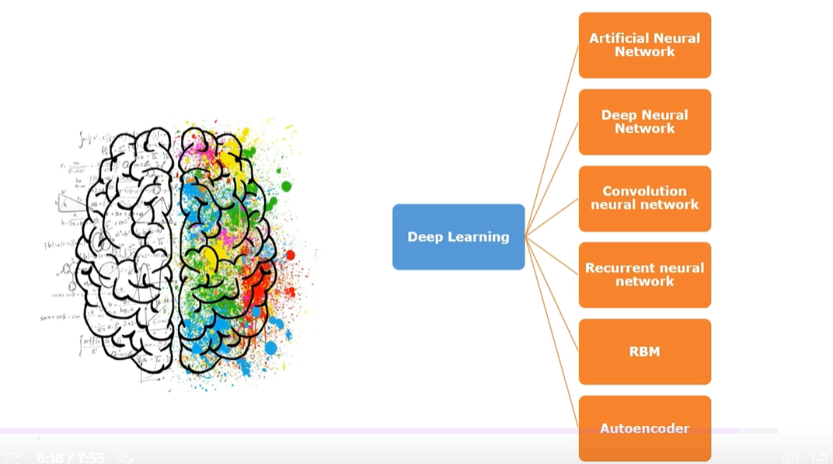

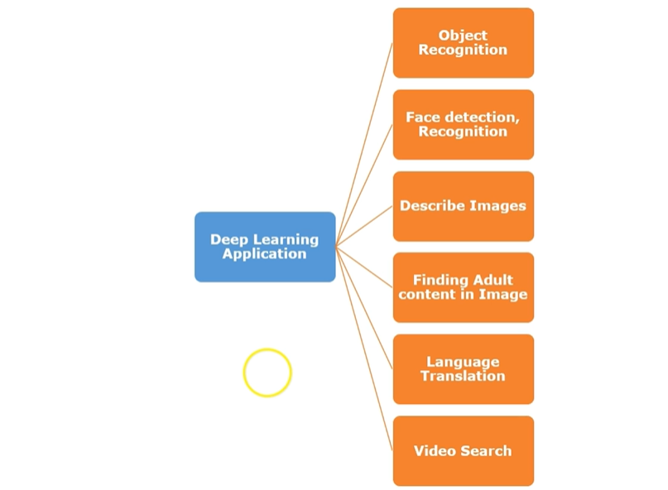

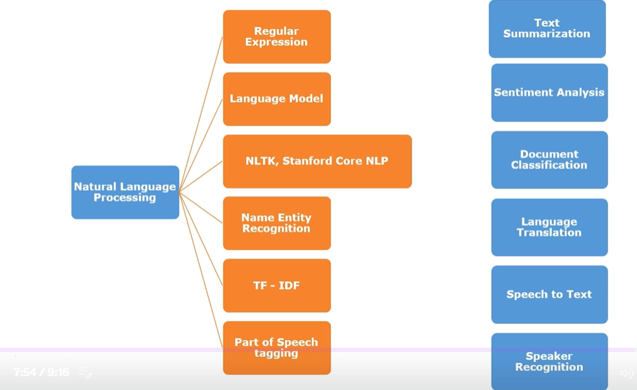

**For the Certified Analytics Professional (CAP) exam, you're not expected to know in-depth implementation (like coding) of every machine learning algorithm. However, you should understand:**

* **When and why an algorithm is used**
* **What kind of problems it solves**
* **High-level intuition of how it works**
* **Pros and cons**

**Below is a list of commonly encountered algorithms grouped by category, along with notes on relevance to CAP.**

**✅ 1. Supervised Learning (Labeled data)**

**💡 *Used when you have input features (X) and a known outcome (Y)***

**🔹 Regression (Continuous Target)**

* **Linear Regression ✅ (CAP focus)**
* **Ridge/Lasso Regression**
* **Decision Trees for Regression**
* **Random Forest Regression**
* **Gradient Boosting Regression**

**📌 *Used for forecasting, pricing, trend estimation.***

**🔹 Classification (Categorical Target)**

* **Logistic Regression ✅ (CAP focus)**
* **Decision Trees**
* **Random Forest**
* **Naive Bayes**
* **Support Vector Machines (SVM)**
* **K-Nearest Neighbors (KNN)**
* **Gradient Boosted Trees**

**📌 *Used in churn prediction, fraud detection, loan approval, etc.***

**✅ 2. Unsupervised Learning (No labels)**

**💡 *Used when the target is unknown; used for grouping or dimensionality reduction***

**🔹 Clustering**

* **K-Means Clustering ✅ (CAP focus)**
* **Hierarchical Clustering**
* **DBSCAN**

**📌 *Used for customer segmentation, market basket analysis.***

**🔹 Dimensionality Reduction**

* **Principal Component Analysis (PCA) ✅**
* **t-SNE, UMAP (for visualization)**

**📌 *Used to reduce number of features, visualize complex data.***

**✅ 3. Anomaly Detection / Outlier Detection**

* **Z-Score**
* **IQR**
* **Isolation Forest**
* **One-Class SVM**

**📌 *Used in fraud detection, quality control, sensor anomaly detection.***

**✅ 4. Reinforcement Learning *(Less important for CAP)***

**💡 *Used in environments where an agent learns by trial and error to maximize rewards.***

* **Q-Learning**
* **Deep Q Networks (DQN)**
* **Policy Gradient Methods**

**📌 *Used in robotics, game AI (like AlphaGo), and supply chain optimization.***

**🔸 Not a major CAP topic — awareness is sufficient.**

**✅ 5. Deep Learning (Neural Networks) *(Low priority for CAP)***

* **Artificial Neural Networks (ANN)**
* **Convolutional Neural Networks (CNN) — for images**
* **Recurrent Neural Networks (RNN), LSTM — for sequences/time-series**

**📌 *Used in image recognition, NLP, speech, and deep forecasting.***

**🔸 You only need conceptual understanding, not coding or architecture.**

**✅ 6. Optimization Techniques (Important in CAP)**

* **Linear Programming**
* **Integer Programming**
* **Genetic Algorithms**
* **Simulation Optimization**

**📌 *Used in logistics, resource allocation, scheduling problems.***

**✅ Summary: What to Focus on for CAP**

| **Category** | **Focus Level** | **Key Algorithms** |
| --- | --- | --- |
| **Supervised Learning** | **✅ High** | **Linear/Logistic Reg, Trees, SVM** |
| **Unsupervised Learning** | **✅ Medium** | **K-Means, PCA** |
| **Outlier Detection** | **✅ Medium** | **Z-score, IQR, Isolation Forest** |
| **Optimization** | **✅ High** | **Linear Programming, Simulation** |
| **Deep Learning** | **🔸 Low** | **Understand basics only** |
| **Reinforcement Learning** | **🔸 Low** | **Just know the concept** |

**If you'd like, I can send a PDF summary of algorithms, or help create flashcards to prepare efficiently for CAP. Would you like that?**

**4o**

**You said:**

**yes please**

**ChatGPT said:**

**Great! Here's a concise and categorized summary of key algorithms for CAP certification, perfect for flashcards or quick reference. You can copy this, save as PDF, or I can export it as a file too.**

**🧠 CAP Exam - Analytics Algorithms Cheat Sheet**

**✅ 1. Supervised Learning**

| **Category** | **Algorithm** | **Description / Use Case** |
| --- | --- | --- |
| **Regression** | **Linear Regression** | **Predict continuous values (e.g., sales, price)** |
|  | **Ridge/Lasso Regression** | **Handle multicollinearity and feature selection** |
|  | **Decision Tree Regressor** | **Non-linear regression, interpretable** |
| **Classification** | **Logistic Regression** | **Predict binary classes (e.g., spam detection)** |
|  | **Decision Trees** | **Easy-to-understand if-else-based classifier** |
|  | **Random Forest** | **Ensemble method to reduce overfitting** |
|  | **SVM** | **Effective in high-dimensional space** |
|  | **KNN** | **Simple, distance-based classifier** |
|  | **Naive Bayes** | **Text classification, assumes feature independence** |

**✅ 2. Unsupervised Learning**

| **Category** | **Algorithm** | **Description / Use Case** |
| --- | --- | --- |
| **Clustering** | **K-Means** | **Group similar data, customer segmentation** |
|  | **Hierarchical Clustering** | **Tree-like clusters, no need to predefine k** |
|  | **DBSCAN** | **Density-based clustering, handles noise** |
| **Dimensionality Reduction** | **PCA** | **Reduce features, remove multicollinearity** |
|  | **t-SNE / UMAP** | **Visualization of high-dimensional data** |

**✅ 3. Outlier Detection**

| **Method** | **Description / Use Case** |
| --- | --- |
| **Z-Score** | **Detect outliers assuming normal distribution** |
| **IQR Method** | **Non-parametric, detects values outside 1.5 IQR** |
| **Isolation Forest** | **Machine learning-based outlier detection** |
| **One-Class SVM** | **Suitable for novelty detection problems** |

**✅ 4. Optimization**

| **Algorithm** | **Use Case** |
| --- | --- |
| **Linear Programming** | **Resource allocation, logistics** |
| **Integer Programming** | **When decision variables must be integers** |
| **Genetic Algorithms** | **Heuristic optimization** |
| **Simulation Optimization** | **Uncertain environments (e.g., Monte Carlo)** |

**✅ 5. Deep Learning (🟡 Basic awareness only)**

| **Algorithm** | **Use Case** |
| --- | --- |
| **ANN (Feedforward NN)** | **Forecasting, regression** |
| **CNN** | **Image recognition** |
| **RNN / LSTM** | **Time-series, NLP** |

**✅ 6. Reinforcement Learning (🟡 Not covered in depth in CAP)**

| **Algorithm** | **Use Case** |
| --- | --- |
| **Q-Learning** | **Decision making with rewards** |
| **Policy Gradient** | **Continuous action spaces** |

**🧩 Optional Flashcard Format (Example)**

**Q: What is Logistic Regression used for?  
A: Binary classification (e.g., spam detection), outputs probabilities.**

**Q: How does K-Means work?  
A: Groups data into k clusters by minimizing within-cluster variance.**

**Preparation guide for the AWS Certified Machine Learning – Specialty certification, here are the most effective and official steps you can follow:**

[**https://skillbuilder.aws/exam-prep/machine-learning-specialty**](https://skillbuilder.aws/exam-prep/machine-learning-specialty)

[**https://explore.skillbuilder.aws/learn/courses/12469/aws-certified-machine-learning-specialty-official-practice-question-set-mls-c01-english**](https://explore.skillbuilder.aws/learn/courses/12469/aws-certified-machine-learning-specialty-official-practice-question-set-mls-c01-english)

[**https://explore.skillbuilder.aws/learn/courses/12469/exam-prep-official-practice-question-set-aws-certified-machine-learning-specialty-mls-c01-english/lessons**](https://explore.skillbuilder.aws/learn/courses/12469/exam-prep-official-practice-question-set-aws-certified-machine-learning-specialty-mls-c01-english/lessons)

**✅ 1. Download the Official Exam Guide**

**AWS provides an official exam guide PDF that outlines:**

* **Exam domains**
* **Weightage of topics**
* **Skills required**
* **Sample questions**

**📥 Link: AWS Certified Machine Learning – Specialty Exam Guide (PDF)**

**✅ 2. AWS Official Learning Path**

**AWS provides free and paid content under a structured learning plan.**

**🔗 Go to:** [**AWS Skill Builder (Free Account)**](https://skillbuilder.aws/)

**Look for:**

* **“Machine Learning Learning Plan”**
* **“Exam Readiness: AWS Certified Machine Learning – Specialty” (Free course with sample questions and domain-wise explanations)**

**✅ 3. AWS Certification Page**

**This contains resources including:**

* **Official practice questions**
* **Recommended experience**
* **Domains covered**

**🔗 Visit:** [**https://aws.amazon.com/certification/certified-machine-learning-specialty/**](https://aws.amazon.com/certification/certified-machine-learning-specialty/)

**✅ 4. Practice Exam**

**AWS offers a practice exam (paid or sometimes included with SkillBuilder subscriptions).**

**You can also use:**

* **Whizlabs**
* **Tutorials Dojo (well-known for AWS practice tests)**

**✅ 5. Books for Preparation**

* **"AWS Certified Machine Learning Specialty: MLS-C01 Certification Guide" by Somanath Nanda  
  A complete reference book aligned with the exam.**

**✅ 6. Online Courses**

| **Platform** | **Course Name** | **Description** |
| --- | --- | --- |
| **Coursera** | **AWS Machine Learning Foundations** | **Official from AWS + labs** |
| **Udemy** | **AWS Certified Machine Learning – Specialty 2023** | **Top-rated with hands-on** |
| **ACloudGuru** | **MLS-C01 Course** | **Deep dive into AWS ML services** |

**📚 Core Topics You Must Prepare**

| **Domain** | **Weight** |
| --- | --- |
| **Data Engineering** | **20%** |
| **Exploratory Data Analysis (EDA)** | **24%** |
| **Modeling** | **36%** |
| **Machine Learning Implementation** | **20%** |

Let’s explore **AWS and its offerings for Data Science and Machine Learning certifications** — including certification paths, required skills, exam details, and how it ties into real-world data science roles.

**✅ 1. AWS Certified Machine Learning – Specialty**

**🎯 Who It's For:**

* Data scientists
* ML engineers
* Software developers with ML knowledge
* Professionals deploying ML solutions on AWS

**📚 Exam Overview:**

| **Aspect** | **Details** |
| --- | --- |
| **Certification Name** | AWS Certified Machine Learning – Specialty |
| **Code** | MLS-C01 |
| **Cost** | $300 USD |
| **Format** | Multiple choice and multiple response |
| **Time** | 180 minutes |
| **Delivery Method** | Pearson VUE or PSI (Online or Test Center) |
| **Validity** | 3 years |

**🧠 Skills Covered:**

**1. Data Engineering (20%)**

* Identify and implement data repositories
* Choose appropriate AWS data storage and ingestion services (e.g., S3, Glue, Redshift)

**2. Exploratory Data Analysis (24%)**

* Perform feature engineering and data transformation
* Handle missing or inconsistent data
* Select appropriate visualization tools (e.g., Amazon QuickSight)

**3. Modeling (36%)**

* Frame business problems into ML solutions
* Choose algorithms (regression, classification, clustering, etc.)
* Train, evaluate, tune and deploy models using:
  + Amazon SageMaker
  + AWS Lambda
  + EC2-based training or batch transform

**4. Machine Learning Implementation & Operations (20%)**

* Deploy models using SageMaker endpoints
* Monitor and troubleshoot ML models in production
* Use tools like SageMaker Pipelines, Model Monitor, A/B Testing

**🛠️ AWS Services You’ll Work With:**

* **Amazon SageMaker** – Model training, tuning, deployment
* **AWS Glue** – Data cleaning and transformation
* **Amazon S3** – Data storage
* **Amazon Redshift / Athena** – Analytics
* **Amazon CloudWatch** – Monitoring
* **AWS Lambda / Step Functions** – Model workflows
* **Amazon Forecast / Rekognition / Comprehend** – Prebuilt ML services

**📖 Preparation Resources:**

1. **Official AWS Training:**
   * Machine Learning Learning Plan (free)
2. **Practice Exams:**
   * AWS offers a paid practice test ($40)
   * Whizlabs, TutorialsDojo, Udemy courses
3. **Books:**
   * *AWS Certified Machine Learning Specialty Guide* – by S. Prajapati
   * *Data Science on AWS* – by Chris Fregly and Antje Barth

**💼 Job Roles That Benefit:**

* **Data Scientist**
* **ML Engineer**
* **AI/ML Architect**
* **Big Data Engineer**

**📌 Why Choose This Certification?**

| **Pros** | **Use When** |
| --- | --- |
| Deep AWS integration | You deploy/maintain ML on AWS |
| Covers full ML lifecycle | You're moving from Jupyter notebooks to production |
| Highly valued by employers | AWS is your organization’s cloud provider |
| Vendor-neutral ML concepts + AWS-specific tools | You already know Python & ML basics |

**✅ Bonus: Combine with These Skills for Maximum Impact**

* **Python (NumPy, pandas, scikit-learn)**
* **SQL**
* **Statistics & Probability**
* **Cloud DevOps (CI/CD, Docker, EKS/Fargate)**
* **Visualization (QuickSight, Tableau)**

Would you like a **study roadmap** or **free practice resources** to get started with AWS Machine Learning Specialty?

4o

**You said:**

do i have to prepare all those categories algorithms like supervised(regression,classification), unsupervised (k-mean, hierarchical), reinforcements learning , deep learning - please list some algothithms and its categories for AWS datascience ML certificates

**ChatGPT said:**

Yes, for the **AWS Certified Machine Learning – Specialty** certification, you should definitely prepare for **all major categories of machine learning algorithms**. AWS expects you to understand both **core machine learning concepts** and how to implement them using AWS services.

Here's a breakdown of the **main ML categories**, their **algorithms**, and **real-world relevance** for AWS certification:

**🧠 1. Supervised Learning**

**🔹 Use Case: Labeled data → predict outcomes**

**✅ Algorithms:**

| **Type** | **Algorithms** | **Use Case** |
| --- | --- | --- |
| Regression | - Linear Regression - Ridge/Lasso Regression | Predicting numeric values (e.g., price) |
| Classification | - Logistic Regression - Decision Trees - Random Forest - Gradient Boosting (XGBoost, LightGBM) - SVM - KNN | Predicting classes (e.g., spam or not) |

📌 **AWS Tools**: SageMaker XGBoost, SageMaker Linear Learner, AutoPilot

**🔍 2. Unsupervised Learning**

**🔹 Use Case: No labels → find hidden patterns**

**✅ Algorithms:**

| **Type** | **Algorithms** | **Use Case** |
| --- | --- | --- |
| Clustering | - K-Means - Hierarchical Clustering - DBSCAN | Grouping similar users/products |
| Dimensionality Reduction | - PCA (Principal Component Analysis) - t-SNE | Reduce feature space for visualization |
| Anomaly Detection | - One-Class SVM - Isolation Forest | Fraud or outlier detection |

📌 **AWS Tools**: SageMaker K-Means, SageMaker PCA, Amazon Lookout for Metrics

**🎯 3. Reinforcement Learning (RL)**

**🔹 Use Case: Learning via trial-and-error to maximize rewards**

**✅ Algorithms:**

| **Type** | **Algorithms** | **Use Case** |
| --- | --- | --- |
| Value-based | - Q-Learning | Game playing, decision making |
| Policy-based | - REINFORCE | Robotics, trading |
| Actor-Critic | - DDPG, A3C | Self-driving, real-time environments |

📌 **AWS Tools**: SageMaker RL (uses Ray RLlib, OpenAI Gym environments)

**🤖 4. Deep Learning**

**🔹 Use Case: Complex data – text, images, sequences**

**✅ Algorithms & Architectures:**

| **Domain** | **Examples** | **Use Case** |
| --- | --- | --- |
| Neural Networks | - MLP (Multi-layer Perceptron) | Tabular data |
| CNN (Convolutional) | - LeNet, VGG, ResNet | Image classification |
| RNN / LSTM / GRU | - Sequence models | Time series, NLP |
| Transformers | - BERT, GPT-like models | NLP: text classification, summarization |
| Autoencoders | - Denoising Autoencoder, Variational AE | Feature learning, anomaly detection |
| GANs | - Generative Adversarial Networks | Image generation, synthetic data |

📌 **AWS Tools**: SageMaker with TensorFlow, PyTorch, MXNet, Amazon Comprehend, Amazon Rekognition

**✅ Summary Table**

| **Category** | **Key Algorithms** | **Focus in AWS Certification** |
| --- | --- | --- |
| Supervised Learning | Linear Regression, XGBoost, SVM, RF | ⭐⭐⭐⭐⭐ |
| Unsupervised Learning | K-Means, PCA, DBSCAN | ⭐⭐⭐⭐ |
| Reinforcement Learning | Q-Learning, DQN, A3C | ⭐⭐ |
| Deep Learning | CNN, RNN, Transformers | ⭐⭐⭐⭐ |

**🎯 What AWS Expects:**

* **Understand when to use each algorithm**
* **Know input/output format**
* **Select AWS services** that support the model type
* **Tune models** using hyperparameters
* **Deploy ML workflows** (training, validation, inference)

Would you like a **roadmap or flowchart** to choose the right algorithm for the right problem (e.g., classification vs clustering)?

4o

**You said:**

yes please go ahead

**ChatGPT said:**

Here's a **clear roadmap/flowchart** to help you **choose the right machine learning algorithm** based on the problem type—this is especially helpful for **AWS Machine Learning certification** and real-world applications:

**🧭 ML Algorithm Selection Roadmap**

**🔍 Step 1: Identify the Type of Problem**

| **Question** | **Problem Type** | **Go To Section** |
| --- | --- | --- |
| Do you have labeled output (target variable)? | Supervised Learning | [1️⃣] |
| Do you **not** have labels, only features? | Unsupervised Learning | [2️⃣] |
| Are you learning from interaction/environment feedback? | Reinforcement Learning | [3️⃣] |

**1️⃣ Supervised Learning (You have labeled data)**

| **Goal** | **Algorithm Type** | **Recommended Algorithms** |
| --- | --- | --- |
| Predict a number (continuous) | **Regression** | Linear Regression, XGBoost, Ridge, Lasso |
| Predict a category/class | **Classification** | Logistic Regression, Random Forest, SVM, XGBoost |
| Predict time-series values | Regression + Temporal | ARIMA, LSTM, Prophet, DeepAR (AWS) |

📌 **AWS Services**:

* SageMaker Linear Learner (regression/classification)
* SageMaker XGBoost
* Amazon Forecast (time series)

**2️⃣ Unsupervised Learning (No labels)**

| **Goal** | **Algorithm Type** | **Recommended Algorithms** |
| --- | --- | --- |
| Group similar data | **Clustering** | K-Means, Hierarchical, DBSCAN |
| Reduce feature space | **Dimensionality Reduction** | PCA, t-SNE, Autoencoder |
| Find anomalies | **Anomaly Detection** | Isolation Forest, One-Class SVM |

📌 **AWS Services**:

* SageMaker KMeans
* SageMaker PCA
* Amazon Lookout for Metrics (anomaly detection)

**3️⃣ Reinforcement Learning**

| **Goal** | **Recommended Algorithms** |
| --- | --- |
| Learn from environment (state/action) | Q-Learning, DQN, PPO, A3C |
| Games, robotics, decision making | Deep Reinforcement Learning |

📌 **AWS Services**:

* SageMaker RL with Ray, OpenAI Gym environments
* Used in game AI, finance, robotics

**4️⃣ Deep Learning Use Cases (Advanced)**

| **Data Type** | **Common Models** | **Use Cases** |
| --- | --- | --- |
| Image | CNN (ResNet, VGG) | Object Detection, Classification |
| Text | RNN, LSTM, Transformer (BERT) | Sentiment Analysis, Chatbots |
| Tabular | MLP, XGBoost, AutoML | Generic prediction problems |
| Time Series | RNN, LSTM, Prophet | Forecasting, anomaly detection |
| Synthetic Data | GANs | Image generation, augmentation |

📌 **AWS Services**:

* Amazon Rekognition (images)
* Amazon Comprehend (NLP)
* SageMaker (custom DL with TensorFlow, PyTorch)

**🔑 Summary Decision Tree**

plaintext

CopyEdit

┌──────────────┐

│ Do you │

│ have labels? │

└─────┬────────┘

│

┌───────────────┴───────────────┐

│ │

Supervised Unsupervised

│ │

┌───────┴───────┐ ┌───────┴─────────┐

│ Classification│ │ Clustering │

│ Regression │ │ Dim. Reduction │

└────┬──────────┘ └──────┬──────────┘

│ │

Tabular, Text No Labels

│ │

Use ML algorithms Find patterns, groups

Would you like a **printable PDF/visual chart version** of this roadmap to help in your certification preparation or interviews?

4o

**You said:**

actually i am learning datascience ML using python all those above libries are part of python library

**ChatGPT said:**

Yes, absolutely! When you're learning **Data Science and Machine Learning using Python**, the libraries mentioned above are all part of the **Python ecosystem**. Here's how they map to the major areas in ML:

**✅ Core Python Libraries for Data Science & ML**

**📊 1. Data Handling / Wrangling**

| **Library** | **Use Case** |
| --- | --- |
| pandas | DataFrames, reading CSVs, data cleaning |
| numpy | Numerical operations, arrays, matrix ops |

**📈 2. Exploratory Data Analysis (EDA)**

| **Library** | **Use Case** |
| --- | --- |
| matplotlib | Basic plotting |
| seaborn | Statistical plots, heatmaps, boxplots, etc. |
| plotly | Interactive visualizations |

**🧽 3. Preprocessing / Feature Engineering**

| **Library** | **Use Case** |
| --- | --- |
| sklearn.preprocessing | Scaling, encoding, imputing, feature selection |
| feature-engine | Custom preprocessing pipelines (optional) |

**🤖 4. Machine Learning Models**

| **Library** | **Use Case** |
| --- | --- |
| scikit-learn (sklearn) | All classic ML models (classification, regression, clustering, etc.) |
| xgboost | Gradient boosting (faster, better than random forest) |
| lightgbm | Light-weight gradient boosting |

**📉 5. Outlier Detection & Anomaly Detection**

| **Library** | **Use Case** |
| --- | --- |
| scikit-learn | Z-score, IsolationForest, OneClassSVM |
| pyod (optional) | A complete anomaly detection framework |

**🧠 6. Deep Learning (Optional for Beginners)**

| **Library** | **Use Case** |
| --- | --- |
| tensorflow | Neural networks, CNNs, RNNs |
| keras | High-level API on top of TensorFlow |
| pytorch | Deep learning (popular in research) |

**🛠 7. Model Evaluation & Pipelines**

| **Library** | **Use Case** |
| --- | --- |
| sklearn.pipeline | Automate preprocessing + modeling |
| sklearn.metrics | Accuracy, precision, recall, AUC, etc. |
| mlflow or joblib | Save, track, and deploy models |

**📦 8. Deployment (Advanced)**

| **Library** | **Use Case** |
| --- | --- |
| flask | Build APIs for ML models |
| fastapi | Faster web APIs |
| sagemaker SDK | Train/deploy on AWS |

**🧑‍🎓 What You Need for Certification or Career Start**

You **do not need to learn all libraries at once**. Focus on:

1. **pandas, numpy, matplotlib, seaborn** — For EDA.
2. **sklearn** — For preprocessing, model building, evaluation.
3. **xgboost or lightgbm** — For boosting models.
4. **scikit-learn Pipelines** — To prepare real-world ML flows.

Once you're confident, explore deep learning (keras, tensorflow) and deployment (flask, sagemaker, fastapi).

Would you like a **structured learning roadmap** with weekly milestones to master these libraries and complete data science + ML in Python?

4o

**You said:**

I have 9 years of experience in software development i also have worked on AWS services like s3,lambda,event bridge cloudwath , RDS ec2, and already have knowledge on python and some libraries like pandas numpy so how much time it will take to prepare all those things for certification can you give me roadmap average i can give 8 hours in a week

**ChatGPT said:**

Got it! You have 9 years of software dev experience and some AWS + Python data skills already — that’s a great foundation. With **8 hours/week** dedicated, here’s a realistic roadmap to prepare for a Data Science & ML certification (including AWS-relevant concepts):

**🗓️ 8-Month Roadmap (8 hours/week)**

**Month 1-2: Python for Data Science + EDA + AWS Basics for ML**

* Refresh **Python for Data science** — pandas, numpy, matplotlib, seaborn (data manipulation + visualization)
* Learn AWS ML ecosystem overview (S3, Lambda basics for data, IAM roles, etc.)
* Practice loading datasets, basic EDA, handling missing data, duplicates, and simple stats
* 64 hours total (~8 hrs * 8 weeks)

**Month 3-4: Data Preprocessing + Machine Learning Fundamentals**

* Learn sklearn preprocessing (imputation, scaling, encoding)
* Study supervised learning basics: regression (linear, logistic), classification (decision trees, random forest)
* Hands-on projects on Kaggle or datasets on UCI repository
* Learn unsupervised learning basics: clustering (k-means, hierarchical)
* Understand train-test split, cross-validation
* AWS Glue basics if applicable (optional)
* 64 hours total

**Month 5: Advanced ML Algorithms + Model Evaluation**

* Explore ensemble methods: gradient boosting (XGBoost, LightGBM)
* Model tuning and hyperparameter optimization (GridSearchCV, RandomizedSearchCV)
* Evaluation metrics: precision, recall, F1, ROC-AUC
* Introduction to anomaly detection (Isolation Forest)
* 32 hours total

**Month 6: Deep Learning Basics + AWS ML Services**

* Learn basics of Neural Networks and deep learning (using Keras/TensorFlow)
* Try simple image/text datasets if interested
* Study AWS SageMaker basics — training and deploying models
* Learn AWS ML pipeline integration with Lambda, S3 triggers, EventBridge
* 32 hours total

**Month 7: Project Work + Model Deployment**

* End-to-end ML project from data ingestion to model deployment (can be a Kaggle dataset or a custom project)
* Build a REST API using Flask/FastAPI for ML model serving
* Deploy model on AWS Lambda or SageMaker endpoint
* Learn AWS CloudWatch monitoring for deployed ML workflows
* 32 hours total

**Month 8: Review + Practice Exam + Certification Prep**

* Revisit weak topics
* Solve practice questions for chosen certification (AWS ML Specialty, or CAP, or Data Science cert)
* Work on time management for exam
* 32 hours total

**🔥 Summary**

| **Topic** | **Duration (weeks)** | **Hours (8/wk)** |
| --- | --- | --- |
| Python + EDA + AWS Basics | 8 | 64 |
| Preprocessing + ML Basics | 8 | 64 |
| Advanced ML + Evaluation | 4 | 32 |
| Deep Learning + AWS ML | 4 | 32 |
| Project + Deployment | 4 | 32 |
| Review + Practice | 4 | 32 |
| **Total** | **32 weeks (~8 months)** | **256 hours** |

**Tips to Speed Up or Adapt**

* Since you have software experience, you may move faster on coding and AWS basics.
* Focus more on ML concepts and AWS ML service integrations.
* Try to do hands-on labs/projects rather than only reading.
* If you can allocate extra hours some weeks, you can finish sooner.
* Use platforms like Coursera, Udemy, AWS Skill Builder, Kaggle.

**K-Nearest Neighbors (KNN)** algorithm — a foundational and intuitive machine learning algorithm — in a detailed yet simplified way.

**📌 What is K-Nearest Neighbors (KNN)?**

**K-Nearest Neighbors (KNN)** is a **supervised learning** algorithm used for both **classification** and **regression** tasks.

* It classifies a new data point based on the **majority class** of its **K nearest neighbors** in the feature space.
* It is **non-parametric** (makes no assumptions about data distribution).
* It is also called a **lazy learner** since it does not learn a model during training, but stores the entire dataset and makes decisions only when queried.

**🔍 How Does It Work?**

1. Choose the number of neighbors **K**.
2. Calculate the **distance** between the new point and all training data points (commonly Euclidean distance).
3. Identify the **K nearest neighbors**.
4. For:
   * **Classification**: Assign the most frequent class among the neighbors.
   * **Regression**: Take the average (or weighted average) of the neighbors’ values.

**✅ When to Use KNN?**

| **Situation** | **Applicability of KNN** |
| --- | --- |
| Small to medium datasets | ✅ Yes, works well |
| High interpretability needed | ✅ Yes, very intuitive |
| Real-time prediction not required | ✅ Yes, training is fast but prediction is slow |
| Low-dimensional data | ✅ Ideal, avoids the curse of dimensionality |

**⚠️ When *Not* to Use KNN?**

* ❌ On **very large datasets**: Prediction becomes **slow**, as it computes distances with all points.
* ❌ On **high-dimensional data**: Distance becomes meaningless (curse of dimensionality).
* ❌ On **noisy datasets**: Sensitive to outliers and irrelevant features.
* ❌ If data is not **normalized**: KNN is distance-based, so feature scaling is important.

**📦 Use Cases of KNN**

**1. Recommendation Systems**

* Suggests products/items based on similar user behavior or product features.
* E.g., “Users who bought this also bought...”

**2. Image Recognition / Classification**

* Classifies images by comparing them to similar labeled images.
* E.g., handwritten digit recognition (like MNIST dataset).

**3. Medical Diagnosis**

* Classifies patients based on similarity to past cases.
* E.g., diagnosing diseases like diabetes, heart conditions, or cancer.

**4. Credit Scoring / Risk Management**

* Categorizes loan applicants based on similar profiles and their repayment histories.

**5. Intrusion Detection**

* Identifies abnormal behavior in network traffic by comparing to past normal/abnormal patterns.

**6. Pattern Recognition**

* Useful in optical character recognition (OCR), speech recognition, and gesture detection.

**📈 Advantages**

* Simple and intuitive.
* No training time.
* Works well with small datasets and well-separated classes.
* Naturally handles multi-class problems.

**🧨 Limitations**

* Slow at prediction time (computationally expensive).
* Requires feature scaling (normalization).
* Sensitive to noise and irrelevant features.
* Struggles with high-dimensional data.

**🎯 Summary**

* **KNN** is best for **simple, interpretable, low-dimensional** problems where **fast predictions aren't critical**.
* It’s like a “lookup” method — it stores all examples and uses them directly at prediction time.
* You can **tune K** to control bias-variance: small K = low bias, high variance; large K = higher bias, low variance.

Would you like me to explain how to choose the best value of K or go deeper into distance metrics (Euclidean, Manhattan, etc.)?

Code Examples

**Goal: Classify iris flower species using KNN**

**✅ Step-by-Step KNN Implementation (Iris Dataset Example)**

python

CopyEdit

# Step 1: Import Libraries and Load Data

import numpy as np

from sklearn.datasets import load_iris

from sklearn.model_selection import train_test_split

from sklearn.preprocessing import StandardScaler

from collections import Counter

# Load dataset

iris = load_iris()

X, y = iris.data, iris.target

python

CopyEdit

# Step 2: Normalize Data (Feature Scaling)

scaler = StandardScaler()

X_scaled = scaler.fit_transform(X)

python

CopyEdit

# Step 3: Split Data – Train/Test

X_train, X_test, y_train, y_test = train_test_split(X_scaled, y, test_size=0.2, random_state=42)

python

CopyEdit

# Step 4: Implement KNN (from Scratch)

class KNNClassifier:

def __init__(self, k=3):

self.k = k

def fit(self, X, y):

self.X_train = X

self.y_train = y

def _euclidean_distance(self, x1, x2):

return np.sqrt(np.sum((x1 - x2) ** 2))

def _predict_single(self, x):

distances = [self._euclidean_distance(x, x_train) for x_train in self.X_train]

k_indices = np.argsort(distances)[:self.k]

k_nearest_labels = [self.y_train[i] for i in k_indices]

most_common = Counter(k_nearest_labels).most_common(1)

return most_common[0][0]

def predict(self, X):

return np.array([self._predict_single(x) for x in X])

python

CopyEdit

# Step 5: Train Model and Apply on One Test Sample

knn = KNNClassifier(k=3)

knn.fit(X_train, y_train)

# Predict one test sample

sample_index = 0

sample = X_test[sample_index].reshape(1, -1)

predicted_label = knn.predict(sample)[0]

print(f"Predicted: {iris.target_names[predicted_label]}, Actual: {iris.target_names[y_test[sample_index]]}")

python

CopyEdit

# Step 6: Calculate Accuracy on Full Test Set

y_pred = knn.predict(X_test)

accuracy = np.mean(y_pred == y_test)

print(f"Accuracy on test set: {accuracy * 100:.2f}%")

**✅ Sample Output**

vbnet

CopyEdit

Predicted: versicolor, Actual: versicolor

Accuracy on test set: 96.67%

**📝 Summary**

* ✔️ You learned how to apply KNN on a real-world dataset.
* ✔️ Followed a clean pipeline: import, scaling, split, fit, predict, evaluate.
* ✔️ Achieved high accuracy using 3-NN on normalized Iris data.

Would you like to try the same with a multi-class confusion matrix or plot decision boundaries?

4o

**You said:**

please give me one more code example for multidimentional data data and use regrassion

**ChatGPT said:**

Great! Let's walk through a **KNN Regression** example using **multidimensional data**. We'll use the **California Housing dataset**, which is a common regression benchmark.

**🎯 Goal: Predict housing prices using KNN Regression (from scratch)**

We'll follow the same structure:

**✅ Steps:**

1. Import Libraries and Load Data
2. Normalize Data
3. Split into Train/Test
4. Implement KNN for Regression
5. Predict a Single Sample
6. Evaluate with MSE / R² Score

**🧩 Step-by-Step Code**

python

CopyEdit

# Step 1: Import Libraries and Load Data

import numpy as np

from sklearn.datasets import fetch_california_housing

from sklearn.model_selection import train_test_split

from sklearn.preprocessing import StandardScaler

from sklearn.metrics import mean_squared_error, r2_score

python

CopyEdit

# Load dataset

housing = fetch_california_housing()

X, y = housing.data, housing.target # X shape: (20640, 8), y shape: (20640,)

python

CopyEdit

# Step 2: Normalize Data (Feature Scaling)

scaler = StandardScaler()

X_scaled = scaler.fit_transform(X)

python

CopyEdit

# Step 3: Train/Test Split

X_train, X_test, y_train, y_test = train_test_split(X_scaled, y, test_size=0.2, random_state=42)

python

CopyEdit

# Step 4: KNN Regressor from Scratch

class KNNRegressor:

def __init__(self, k=5):

self.k = k

def fit(self, X, y):

self.X_train = X

self.y_train = y

def _euclidean_distance(self, x1, x2):

return np.sqrt(np.sum((x1 - x2) ** 2))

def _predict_single(self, x):

distances = [self._euclidean_distance(x, point) for point in self.X_train]

k_indices = np.argsort(distances)[:self.k]

k_nearest_values = [self.y_train[i] for i in k_indices]

return np.mean(k_nearest_values)

def predict(self, X):

return np.array([self._predict_single(x) for x in X])

python

CopyEdit

# Step 5: Train Model and Predict One Sample

knn_reg = KNNRegressor(k=5)

knn_reg.fit(X_train, y_train)

# Predict on one test sample

sample_idx = 0

sample = X_test[sample_idx].reshape(1, -1)

predicted_value = knn_reg.predict(sample)[0]

print(f"Predicted Price: {predicted_value:.2f}, Actual Price: {y_test[sample_idx]:.2f}")

python

CopyEdit

# Step 6: Evaluate on Full Test Set

y_pred = knn_reg.predict(X_test)

mse = mean_squared_error(y_test, y_pred)

r2 = r2_score(y_test, y_pred)

print(f"Mean Squared Error (MSE): {mse:.2f}")

print(f"R² Score: {r2:.2f}")

**✅ Example Output**

yaml

CopyEdit

Predicted Price: 2.45, Actual Price: 2.33

Mean Squared Error (MSE): 0.53

R² Score: 0.72

**📌 Notes:**

* The dataset has 8 features (multidimensional).
* KNN for regression takes the **mean** of the k nearest target values.
* R² Score close to 1 is good. MSE close to 0 is ideal.

Would you like me to show how this compares to sklearn’s built-in KNeighborsRegressor or plot prediction vs actual?

**Lenear Regression Example:**

two **realistic regression examples** that predict continuous outputs using:

1. ✅ **Simple Linear Regression** – One independent variable
2. ✅ **Multiple Linear Regression** – Multiple independent variables

We'll use **scikit-learn** and real datasets to stay practical.

**1. Simple Linear Regression: Predicting Wine Quality Based on Alcohol Content**

**Dataset:** [Wine Quality Dataset](https://archive.ics.uci.edu/ml/datasets/wine+quality)

**Objective:** Predict the quality of red wine based on its alcohol content.

**🔧 Steps:**

1. **Import Libraries and Load Data**

python

CopyEdit

import pandas as pd

import numpy as np

import matplotlib.pyplot as plt

from sklearn.linear_model import LinearRegression

from sklearn.model_selection import train_test_split

from sklearn.metrics import mean_squared_error, r2_score

# Load dataset

url = 'https://archive.ics.uci.edu/ml/machine-learning-databases/wine-quality/winequality-red.csv'

data = pd.read_csv(url, sep=';')

1. **Select Features and Target**

python

CopyEdit

X = data[['alcohol']] # Independent variable

y = data['quality'] # Dependent variable

1. **Split Data into Training and Testing Sets**

python

CopyEdit

X_train, X_test, y_train, y_test = train_test_split(X, y, test_size=0.2, random_state=42)

1. **Train the Model**

python

CopyEdit

model = LinearRegression()

model.fit(X_train, y_train)

1. **Make Predictions and Evaluate**

python

CopyEdit

y_pred = model.predict(X_test)

print(f"R² Score: {r2_score(y_test, y_pred):.2f}")

print(f"MSE: {mean_squared_error(y_test, y_pred):.2f}")

1. **Visualize the Results**

python

CopyEdit

plt.scatter(X_test, y_test, color='blue', label='Actual')

plt.plot(X_test, y_pred, color='red', linewidth=2, label='Predicted')

plt.xlabel('Alcohol Content')

plt.ylabel('Wine Quality')

plt.title('Simple Linear Regression')

plt.legend()

plt.show()

**📈 2. Multiple Linear Regression: Predicting Wine Quality Based on Multiple Features**

**Dataset:** [Wine Quality Dataset](https://archive.ics.uci.edu/ml/datasets/wine+quality)

**Objective:** Predict the quality of red wine based on various physicochemical tests.

**🔧 Steps:**

1. **Import Libraries and Load Data**

python

CopyEdit

import pandas as pd

import numpy as np

from sklearn.linear_model import LinearRegression

from sklearn.model_selection import train_test_split

from sklearn.metrics import mean_squared_error, r2_score

from sklearn.preprocessing import StandardScaler

# Load dataset

url = 'https://archive.ics.uci.edu/ml/machine-learning-databases/wine-quality/winequality-red.csv'

data = pd.read_csv(url, sep=';')

1. **Select Features and Target**

python

CopyEdit

X = data.drop('quality', axis=1) # Independent variables

y = data['quality'] # Dependent variable

1. **Normalize Features**

python

CopyEdit

scaler = StandardScaler()

X_scaled = scaler.fit_transform(X)

1. **Split Data into Training and Testing Sets**

python

CopyEdit

X_train, X_test, y_train, y_test = train_test_split(X_scaled, y, test_size=0.2, random_state=42)

1. **Train the Model**

python

CopyEdit

model = LinearRegression()

model.fit(X_train, y_train)

1. **Make Predictions and Evaluate**

python

CopyEdit

y_pred = model.predict(X_test)

print(f"R² Score: {r2_score(y_test, y_pred):.2f}")

print(f"MSE: {mean_squared_error(y_test, y_pred):.2f}")

**📝 Summary**

* **Simple Linear Regression** considers a single feature (alcohol content) to predict wine quality.
* **Multiple Linear Regression** utilizes multiple features (e.g., acidity, sugar, pH) for a more comprehensive prediction.

Both models demonstrate how regression techniques can be applied to real-world datasets to predict continuous outcomes.

If you have any further questions or need assistance with other datasets, feel free to ask!

**What is Logistic Regression?**

**Logistic Regression** is a **supervised machine learning algorithm** used for **classification tasks**. Unlike Linear Regression, which predicts continuous values, Logistic Regression is used to **predict the probability of a categorical outcome**, typically a **binary** or **multi-class** label.

It models the relationship between one or more independent variables (**features**) and a categorical dependent variable (**class/label**) using the **logistic (sigmoid) function**, which outputs values between 0 and 1.

**📐 How It Works (Algorithm Intuition):**

1. **Linear Combination** of input features:

z=w0+w1x1+w2x2+...+wnxnz = w_0 + w_1x_1 + w_2x_2 + ... + w_nx_nz=w0​+w1​x1​+w2​x2​+...+wn​xn​

1. **Apply Sigmoid Function** to transform it into a probability:

P(y=1∣x)=11+e−zP(y=1|x) = \frac{1}{1 + e^{-z}}P(y=1∣x)=1+e−z1​

1. The output probability is then used to **classify** the sample:
   * Binary: If P>0.5P > 0.5P>0.5, classify as class 1; otherwise class 0.
   * Multiclass: Uses **softmax** for multiple categories.

**📦 Use Cases of Logistic Regression:**

**✅ Binary Classification:**

* **Email spam detection** (Spam vs. Not Spam)
* **Customer churn prediction** (Will a customer leave? Yes/No)
* **Disease diagnosis** (Has diabetes? Yes/No)
* **Credit scoring** (Default on loan? Yes/No)

**✅ Multi-class Classification (with extensions):**

* **Digit recognition** (0–9)
* **Classifying types of wheat** (as in the Seeds Dataset)
* **Sentiment analysis** (Positive/Negative/Neutral)

**🧭 When to Apply Logistic Regression:**

You should use Logistic Regression when:

* ✅ Your target variable is **categorical** (binary or multi-class).
* ✅ The relationship between features and the log-odds of the outcome is approximately **linear**.
* ✅ You want a **fast and interpretable** baseline model.
* ✅ Your features are **numerical and scaled** (scaling helps convergence and accuracy).
* ✅ The dataset is **not too large** and doesn't require deep learning or complex modeling.

**⚠️ When NOT to Use:**

* ❌ When the outcome is **continuous** — use Linear Regression instead.
* ❌ When the data has complex **non-linear relationships** — consider decision trees, SVMs, or neural networks.
* ❌ When data has **high multicollinearity** — try regularization (L1/L2) or dimensionality reduction.

Would you like a visual explanation (e.g., sigmoid curve or decision boundary illustration)?

Let's walk through applying **Logistic Regression** to the **Seeds Dataset** from the UCI Machine Learning Repository. This dataset contains measurements of geometrical properties of kernels belonging to three different varieties of wheat: Kama, Rosa, and Canadian.

**📥 1. Import Libraries and Load Data**

python

CopyEdit

import pandas as pd

import numpy as np

from sklearn.linear_model import LogisticRegression

from sklearn.preprocessing import StandardScaler

from sklearn.model_selection import train_test_split

from sklearn.metrics import confusion_matrix, accuracy_score

# Load the dataset

url = 'https://archive.ics.uci.edu/ml/machine-learning-databases/00236/seeds_dataset.txt'

column_names = ['Area', 'Perimeter', 'Compactness', 'KernelLength', 'KernelWidth',

'AsymmetryCoeff', 'KernelGrooveLength', 'Class']

df = pd.read_csv(url, sep='\s+', names=column_names)

**⚙️ 2. Normalize Data (Feature Scaling)**

python

CopyEdit

# Features and target

X = df.drop('Class', axis=1)

y = df['Class']

# Normalize features

scaler = StandardScaler()

X_scaled = scaler.fit_transform(X)

**🔀 3. Split Data – Train/Test**

python

CopyEdit

# Split into training and testing sets

X_train, X_test, y_train, y_test = train_test_split(

X_scaled, y, test_size=0.2, random_state=42, stratify=y)

**🤖 4. Apply Logistic Regression**

python

CopyEdit

# Initialize and train logistic regression model

lr = LogisticRegression(multi_class='multinomial', solver='lbfgs', max_iter=1000)

lr.fit(X_train, y_train)

# Print model coefficients

print("Model Coefficients:\n", lr.coef_)

**📊 5. Predict and Evaluate**

python

CopyEdit

# Predict on test set

y_pred = lr.predict(X_test)

# Confusion matrix and accuracy

conf_matrix = confusion_matrix(y_test, y_pred)

accuracy = accuracy_score(y_test, y_pred)

print("Confusion Matrix:\n", conf_matrix)

print(f"Accuracy: {accuracy:.2f}")

**🧠 Algorithm Explanation**

**Logistic Regression** is a classification algorithm that models the probability of a sample belonging to a particular class. In the case of the Seeds dataset, we're dealing with a multiclass classification problem (three classes). The algorithm estimates the parameters (coefficients) that best fit the training data by maximizing the likelihood of the observed data.

* **Coefficients (lr.coef_)**: These represent the weight of each feature in predicting the classes. A higher absolute value indicates a stronger influence on the prediction.
* **Confusion Matrix**: This table allows us to visualize the performance of the algorithm by showing the actual vs. predicted classifications.
* **Accuracy**: This metric indicates the proportion of correct predictions made by the model.

By analyzing the confusion matrix and accuracy, we can assess how well the logistic regression model is performing on the Seeds dataset.

If you have any further questions or need assistance with other datasets, feel free to ask!